Supplementary Material
GNN-Indoor ELCT: A Generalizable Broadband Indoor Propagation Framework Based on Graph Neural Networks Integrated with Electrically Large Cavity Topology
Juting Hong, Xiang Zhao, Kai Song, Changjun Liu, and Liping Yan
College of Electronics and Information Engineering, Sichuan University, Chengdu 610065, China
Part A. Detailed Geo-ELCT Translator Algorithm

Supplementary Algorithm S1. Geo-ELCT Translator With Self-Correction and Topology Checking
This algorithm specifies the map-to-table translator. All lengths are in pixels and areas in pixels squared. The two geometry inputs are the room-region map $W$ and opening map $O$, of equal raster size. The outputs are the room-parameter table $T_{R}$, inter-room interface table $T_{E}$, and topology $G$ represented by room/interface records and a visualization. A background image is used only to draw the visualization; it supplies no geometric evidence. The direct command-line interface can reuse $W$ as that background. The manuscript input names wall_svg and icon_svg correspond to W and O, respectively.
S0. Conventions, input checks, and execution order
- Load palette-index maps and require equal image dimensions and array shapes. On the formal interface, verify declared input hashes/dimensions when a case configuration supplies them, verify source identity, and preserve run-local input copies. Invalid input/source identity or I/O can raise an exception. There is no additional semantic-label validator in this path.
- Let wall pixels satisfy $W=2$, and let $X=\{0,1,2,8,50\}$ be the excluded room labels. Eligible room labels are all observed labels outside $X$. In raw $O$, 0 is empty, 1 denotes window, and 2 denotes door. Tests for any nonzero icon are explicitly distinguished below from tests for only classes 1 and 2.
- Let $D_{r}(C)$ be square dilation of pixel set $C$ with a $(2r+1)×(2r+1)$ all-ones kernel, clipped to the image; the exterior ring is $D_{r}(C)\text{∖}C$. An inclusive bounding box has row/column spans $h,w$. “Horizontal” means longitudinal columns and transverse rows; the vertical case exchanges rows and columns.
- Connected components use OpenCV label order. Sort semantic room labels increasingly. Raw opening classes are processed as 1, then 2. Preserve this ordering wherever an update or first qualifying candidate is specified.
- Execute S1 (fragments), S2 (wall boundaries), S3 (wall gaps), and S4–S6 (opening repair), in that order. The first three update $W$ and use the original $O$. Opening repair then updates $O$ against the repaired $W$.
- Execute the complete baseline extraction, S7–S10, exactly once on the corrected maps. Temporary room extraction for S3 side evidence and S4 host evidence is separate from this final extraction. Export in S11, then report checks in S12. Checks do not feed back into correction.
S1. Enclosed room fragments
- On the stage-input $W$, enumerate 8-connected components of every eligible semantic label. Let their areas be $A_{j}$. Set $A_{\text{ref}}$ to the median of the areas strictly greater than 160; if that set is empty, use the median of all $A_{j}$; if there are no components, set $A_{\text{ref}}=0$.
- Set the relative cap to $0.002A_{\text{ref}}$ when $A_{\text{ref}}>0$, otherwise to infinity. Set $A_{\text{cap}}=\text{min}(160,\text{relative cap})$.
- For each original component $C$ of semantic label $s$, let $A_{f}=\text{|}C\text{|}$. If $A_{f}>A_{\text{cap}}$, preserve it. Otherwise form touch ring $D_{1}(C)\text{∖}C$ and dominance ring $D_{2}(C)\text{∖}C$.
- Preserve $C$ if its touch ring contains any $W$ label in $X$ or any $O$ value in $\{1,2\}$. All four excluded labels other than the wall label are protected here, regardless of exterior connectivity. The opening protection examines the ring; it is not an additional opening-overlap test inside $C$.
- Among touch-ring labels outside $X$ and different from $s$, require exactly one host label $q$. Otherwise preserve $C$.
- In the dominance ring count only labels outside $X$ and different from $s$. Let $n_{q}$ be the largest label count and $N$ the sum of these eligible counts. Require $N>0$, $n_{q}/N≥0.80$, and that the dominant label equals the touch-ring host. Otherwise preserve $C$.
- Relabel every accepted $C$ to its host label in an output copy. Evaluate all components and neighborhoods on the original stage-input maps; do not reconsider neighboring components after a relabel. Rings follow raster clipping; no separate image-border test is present. This is one pass and never erases a room component to background.
S2. Wall-boundary regularization
S2.1. One-pixel bulges
- Compute wall mask $B=(W=2)$. Examine top, bottom, left, and right sides, in that order. On each eligible row or column, enumerate contiguous candidate runs for which the candidate pixel and its first inward neighbor are wall and its first outward neighbor is not a wall pixel. Each run is one pixel thick.
- Require longitudinal span $ℓ≤20$. Require both longitudinal 6-pixel extensions and the three inward body layers to fit entirely inside the image; otherwise skip the run.
- Let $f_{b}$ be the wall fraction of the three-layer inward body over the candidate span. Let $f_{\text{-}}$ and $f_{\text{+}}$ be wall fractions of the 6-pixel extensions on the first inward row/column. Require $f_{b}≥0.98$ and $\text{min}(f_{\text{-}},f_{\text{+}})≥0.98$.
- Require both immediately adjacent longitudinal endpoint pixels on the candidate layer not to be wall pixels. This distinguishes a local protrusion from part of a longer boundary.
- Sample semantic labels along the outward neighboring line and at the two candidate-layer endpoint pixels. Remove labels in $X$ from the count. Require a dominant remaining room label $q$ with fraction at least 0.95 among the remaining samples. Require $O=0$ on every candidate pixel.
- Accumulate accepted pixels and their replacement host labels, using the original stage-input wall mask for all judgments. Relabel accepted pixels to their host labels after candidate evaluation. If accepted candidates overlap, the later assignment in the retained iteration order supplies the replacement label.
S2.2. One-pixel holes
After bulge relabeling, recompute the wall mask. Simultaneously fill each pixel satisfying $W=0$, $O=0$, and four orthogonal wall neighbors. Treat padding outside the image as pixels not labeled as walls for this test. There is no component-area test and no repeated filling pass. S2 does not translate whole walls or repair general boundary displacement.
S3. Short-wall-gap reconstruction
S3.1. Proposals and common gates
- From the stage-input repaired $W$, form $B=(W=2)$ and extract temporary 8-connected room instances $R$ as in S7. Keep $B$, $R$, and $W$ fixed during candidate judgment.
- Propose horizontal added pixels using morphological closing of $B$ with a $1×8$ all-ones kernel, intersected with $¬B$ and $W=0$. Propose vertical added pixels using an $8×1$ kernel in the same way. Use OpenCV’s default anchor and border behavior; the even-size kernels are not replaced by centered odd kernels.
- Process horizontal proposals before vertical proposals; split each mask into 8-connected components. For each nonempty component, first attempt the terminal expansion in S3.3. Then deduplicate by the resulting inclusive bounding box across both orientations, retaining the first occurrence.
- Let $ℓ_{g}$ be the bounding box span along the proposed direction and $t_{g}$ its transverse span. Require $ℓ_{g}≤6$ and candidate pixel count $≤512$. The two-ended proposal need not occupy its entire bounding box; its area gate uses actual candidate pixels.
- Require no nonzero icon in the candidate bounding box expanded by one pixel in every direction and clipped to the image.
- Sample 4-pixel strips immediately on the two transverse sides of the bounding box, over its longitudinal span. In each strip, count only positive temporary room IDs. Require a dominant ID on each side, distinct dominant IDs, and dominance at least 0.90 on each side. Each denominator is that strip’s total positive-ID count. Equal semantic room classes are allowed if their instance IDs differ. Semantic side-label statistics are not acceptance gates.
- Apply S3.2 to ordinary bridge candidates or S3.3 to expanded terminal candidates. Accept only when the applicable branch and every common gate pass. Accumulate accepted coordinates; after all candidates are judged, set these coordinates to wall label 2. Do not regenerate proposals or room IDs within this pass.
S3.2. Two-ended bridge
- Sample the immediately preceding and following longitudinal cross-sections over the bounding box transverse range. If either cross-section is unavailable, alignment and both wall counts are zero. Otherwise let $n_{\text{-}},n_{\text{+}}$ be their wall-pixel counts and $a$ the fraction of transverse positions that are wall at both ends.
- Require $a≥0.90$, $\text{|}n_{\text{-}}−n_{\text{+}}\text{|}≤2$, and $\text{min}(n_{\text{-}},n_{\text{+}})≥\text{max}(1,t_{g}−1)$.
- Sample each end’s 6-pixel longitudinal extension across the full transverse bounding box span. If either full extension lies outside the image, return zero support. Otherwise require the wall fraction of each extension to be at least 0.95.
- These are joint compatibility conditions with S3.1; no independent scalar “compatible-wall threshold” exists.
S3.3. Terminal gap
- Before expansion, compute the end counts as in S3.2. Enter the terminal search only if exactly one end has a positive wall count. Otherwise leave the proposal unchanged and use the bridge branch.
- Start at the proposal’s longitudinal bounding box end nearest the supported wall; move away from that wall. Test offsets 0 through 5, at most six positions. At each position use the original bounding box transverse range.
- If the tested cross-section is entirely $W=0$, collect that position and continue. At the first cross-section that is not entirely zero, save it as the terminal boundary and stop. Stop on image exit. If all six positions were zero, the boundary remains empty. If no zero position was collected, do not designate a terminal candidate and use the ordinary bridge branch with the original proposal.
- Otherwise replace the candidate by the complete rectangle over the collected zero cross-sections and designate it terminal, even if its terminal boundary will subsequently fail. Do not fall back to a bridge after failed terminal acceptance.
- Require a nonempty terminal boundary with an eligible room label. Its dominant eligible semantic label must account for at least 0.90 of eligible room samples. Also require every boundary value to differ from both 0 and 2. Labels 1,8,50 are excluded from the dominance denominator but are not individually prohibited by this last all-values test.
- Recompute end counts and independent 6-pixel support fractions on the expanded bounding box. Require $\text{max}(n_{\text{-}},n_{\text{+}})≥\text{max}(1,t_{g}−1)$ and the maximum of the two support fractions to be at least 0.95. The support helper returns both fractions as zero if either full extension is out of the image.
- Apply all common gates in S3.1. The terminal branch does not require bridge overlap $≥0.90$ or endpoint-count difference $≤2$. Its six-position search includes the terminating room section; consequently six all-zero positions do not form an accepted terminal gap. The accepted zero run in this branch is at most five positions.
S4. Opening-host and collision predicates
S4.1. Fixed room and outside evidence
Extract temporary room-instance map $R$ from the fully repaired $W$ once. Build qualified outside mask $Q$ from 4-connected components of $W∈\{0,1,8,50\}$ that touch any image border. Use this fixed $R,Q,W$ throughout opening completion and movement. Enclosed background components are not qualified outside.
S4.2. Opposed-domain host H
For component coordinates $C$, choose the longer bounding box axis. When width equals height and no explicit axis was supplied, the host is invalid. A completion proposal supplies an explicit axis from shared transverse extents, so square/aspect-inverted fragments can be evaluated along that axis.
- At every longitudinal position of the component bounding box, consider component pixels lying on that transverse scanline. Their subset with $W=2$ must be nonempty and must form a contiguous interval in the transverse coordinate. A gap in this subset or a line with no wall support invalidates the host.
- Starting immediately beyond each endpoint of that wall-supported interval, probe in the opposite normal directions. Examine at most three positions. At each position: image exit yields domain outside; a pixel not labeled as a wall and with positive $R$ yields that room ID; a pixel not labeled as a wall that belongs to $Q$ yields outside; any other pixel not labeled as a wall yields unknown; a wall pixel advances the probe. If no domain was found within the three inspections, return unknown. Thus a successful probe can cross at most two additional wall pixels.
- Require both probe domains known and different, with at least one room ID. Require every longitudinal position to yield the same ordered pair. Its sorted two-domain set is the host signature $σ(C)$. Room–room and room–outside are both permitted.
- In $D_{2}(C)$, collect all positive room IDs. Reject if any is absent from $σ(C)$. This uses a square neighborhood, including the original footprint, not only two normal strips.
- Define $H(C)$ true precisely when all lines are supported, there is exactly one ordered pair and exactly two signature domains, no extra nearby room, and no unsupplied square-axis ambiguity. A uniform wall interval across all lines is recorded separately and is required only by S6.1’s exterior-face rule.
S4.3. Collision K
For proposed target footprint $C′$ and the current component footprint $C$ (or both parent pieces for completion), inspect $D_{1}(C′)$ in the current mutable $O$. Temporarily remove only the original footprint $C$ from that inspection. Any remaining nonzero icon is a collision. This prohibits contact with both same-type and different-type icons and with other nonzero labels. It does not exclude an entire component merely because it has the same type.
S5. Opening band completion between remaining pieces
For raw class 1 then class 2, perform at most eight passes. At each pass:
- Recompute that class’s 8-connected components from the current $O$. Enumerate pairs in component order.
- If two pieces have identical inclusive row extents, propose a horizontal rectangular gap between them. Otherwise, if they have identical inclusive column extents, propose a vertical gap. If neither matches, reject the pair. Require longitudinal gap $g$ to satisfy $1≤g≤4$. The first matching extent branch is retained; do not try an alternative axis after its gap test fails.
- Let $F$ be all pixels in that rectangular band and $C′=C_{a}∪C_{b}∪F$. Evaluate both parents and $C′$ with the proposed axis supplied to H. Require all three hosts valid and all three sorted signatures equal.
- Require every fill pixel to satisfy $W=2$ and $O=0$. Require no collision for $C′$ after excluding both parents. If a geometrically proposed pair fails these host/fill/collision gates, preserve its pixels and record an unresolved proposal event.
- Among accepted proposals, count the number of admissible partners for each component. Select pairs for which each parent has exactly one admissible partner. If none exist, report multiple-partner events for admissible candidates where present and end this class’s completion loop.
- Otherwise complete only the first qualifying pair in retained enumeration order by assigning class label to $F$, record the merge, and begin the next pass with recomputed components. Budget exhaustion ends the loop; it does not itself create a separate unresolved-budget event.
This operation requires remaining pieces, shared transverse extents and supported hosts; it is not general reconstruction of every incomplete opening. It has no additional two-indoor-room restriction and no independent full-wall-thickness, rectangular-parent-fill, or 0.995-overlap gate. The missing band is internal to the two-remnant footprint; its host may include outside. Full-wall-thickness coverage belongs to the separate original-position exception below. The completed component is still processed and verified in S6.
S6. Original-position acceptance, displacement, erasure, and unresolved components
Freeze a copy of $O$ after S5 solely for component enumeration. Iterate its 8-connected components for raw class 1 then 2. Keep current mutable $O$ for collision tests and updates. For each component $C$, compute $H(C)$ and wall overlap $ω(C)=\text{|}\{p∈C:W(p)=2\}\text{|}/\text{|}C\text{|}$.
S6.1. Separate original-position exterior-face exception E
E is true only if all of the following hold:
- H is valid, its signature includes outside, its wall interval is identical on every longitudinal line, and the component completely fills its bounding box (fill fraction exactly 1).
- Relative to the uniform wall interval, exactly one transverse bounding box face extends beyond it by a positive number of pixels at most 1, while the other face has zero excess. Negative excess is not accepted.
- At each immediately adjacent transverse wall-band face that is inside the image, no wall pixel exists over the full longitudinal bounding box span. This prevents accepting an opening that leaves an uncovered wall layer at the opposite face.
- The component contains at least one pixel not labeled as a wall, and all such pixels belong to the qualified outside mask $Q$.
E preserves the original footprint. It is never used to make a displacement candidate legal, and it does not lower the strict overlap threshold.
S6.2. Ordered component decision
- If $H(C)$, no collision, and $ω(C)≥0.995$ or E (with the disjunction inside the preceding conjunction), keep the original component as valid and continue.
- Otherwise, if the original component has a collision, preserve it as unresolved and continue. Do not slide contacting components apart automatically.
- Otherwise, erase only if $\text{|}C\text{|}≤8$, no wall exists anywhere in $D_{3}(C)$, and the component is isolated under S4.3. Record the deletion for review. This square envelope covers the permitted shift disk; the criterion is independent invalid-speck evidence, not failed search.
- Otherwise enumerate all integer shifts $d=(d_{y},d_{x})$ with $d_{y},d_{x}∈[−3,3]$ and $∥d∥_{2}≤3$, including zero. A candidate $C+d$ is legal only if every coordinate is inside the image, $ω(C+d)≥0.995$, there is no collision with current icons excluding the original $C$, and $H(C+d)$ is valid. The candidate’s host signature is not required to equal the original signature.
- Rank legal candidates by maximum $ω$ first and minimum $∥d∥_{1}$ second. Compare the two ranking values exactly; dx/dy iteration order is not an additional tie breaker. If exactly one candidate has the best ranking pair, erase the original coordinates and write the same class at the shifted coordinates. Otherwise preserve $C$ as unresolved, distinguishing no legal shift from tied best shifts.
S6.3. Final opening verification
After all component decisions, enumerate final 8-connected class-1/class-2 components from current $O$. A component verifies iff H is valid, it is collision-free, and its overlap is at least 0.995 or it satisfies E at its current footprint. Record final unverified components separately from all unresolved proposal/component events. Record completion and deletion counts separately. This pass only evaluates status; it makes no map changes and does not undo prior actions. Save corrected maps and use them for S7–S11 regardless of unresolved status.
S7. Final room parameters and two wall-count bounds
- Enumerate eligible semantic labels increasingly, then their 8-connected components in OpenCV order. Assign global room IDs starting at 1; pixels not assigned to a room have ID 0. Set $A_{i}$ to component pixel count. Room-type labels are 3: Kitchen, 4: Living Room, 5: Bedroom, 6: Bath, 7: Hallway, 9: Storage, and 10: Garage; other eligible labels are Other.
- Compute $P_{i}$ as the sum of binary pixels in the component’s $3×3$ all-ones morphological gradient. This includes the gradient footprint, not an analytic contour length.
- Set $b_{\text{in}}=\text{round}({\text{min}}_{i}(P_{i}/10))$, with the implemented Python rounding and integer conversion applied in the internal ray consumer. Set $b_{\text{out}}=P_{\text{last}}/10$ without rounding; last means the last room in the preceding enumeration, and this one exterior bound is used for every room. If no room exists, both returned bounds are zero.
- For either bound, maintain cumulative wall-pixel count $c_{w}$ along each ray. Immediately reject that ray when $c_{w}≥b$. Do not count total traveled pixels as wall thickness. Use the four cardinal directions only, in up/down/left/right order, from room pixels with at least one cardinal neighbor outside the room or image.
S8. Internal interfaces: openings, then walls, then open space
S8.1. Internal doors and windows
- For the internal extractor only, recode raw opening labels 1->2 (window) and 2->1 (door); initialize other entries as zero. Process doors first, windows second.
- Split the class mask into 4-connected components. Collect distinct positive room IDs in the cardinal neighbors of every component pixel. Emit an internal opening only if exactly two IDs occur; order the two IDs increasingly.
- Measure bounding box long dimension as length and short dimension as width. Aggregate by room pair and type: increment number of components and sum both lengths and widths. Retain this aggregation before wall extraction. Do not substitute mean thickness or infer an aperture not incident under this test.
S8.2. Internal walls
- For each room, each cardinal boundary pixel, and each cardinal direction, start at the neighboring pixel. Reject an immediate image exit, return into the source room, or an excluded background label other than the wall label at the first step.
- Advance along the ray. At any image exit, reject. If a room is reached, accept only a different positive room ID after at least one wall pixel; reaching the source room or another room with no wall traversed fails. Any label in $\{0,1,8,50\}$ blocks the ray.
- At $W=2$, collect that pixel and increment $c_{w}$; reject immediately when $c_{w}≥b_{\text{in}}$. Any remaining pixel that is not assigned to a room, is not blocked, and is not labeled as a wall simply advances the loop. In the canonical room map, every pixel whose semantic label is outside the excluded set already has a room ID.
- Union accepted wall-pixel sets by unordered source/target room pair, then split each union into 4-connected components. For a component of area $A$ and bounding box $h×w$, set length $L=\text{max}(h,w)$ and width $t=\text{min}(\text{min}(h,w),\text{max}(1,\text{round}(A/L)))$. Emit one wall edge per such component. Wall pixels under door/window icons are not subtracted by this routine.
S8.3. Direct open-space interfaces
Scan every positive room pixel and its right/down neighbors. If a neighbor has a distinct positive room ID and zero binary-wall value, collect the source pixel for that unordered room pair. Build one mask per pair, split into 4-connected components, and emit type opening with length=max(bounding box dimensions) and width=min(bounding box dimensions). This type denotes open space, not a class in the door/window input map.
S9. Exterior walls followed by exterior openings
S9.1. Exterior wall rays and aggregation
- After all S8 interfaces, scan room/cardinal-boundary/cardinal-direction combinations. An out-of-image first step or first step into the source room fails.
- Advance while inside the image. When a pixel not assigned to a room whose label is in $\{0,1,8,50\}$ is reached, return the accumulated wall set only if nonempty. For $W=2$, collect it, increment $c_{w}$, and reject immediately on $c_{w}≥b_{\text{out}}$. Any positive room ID fails. After later image exit, return a nonempty accumulated wall set; otherwise fail.
- For each room, deduplicate identical ray wall-pixel sets. A row-direction ray yields a horizontal wall orientation, with length equal to the column span and thickness equal to the row span; a column-direction ray uses the converse. Merge records with equal orientation and thickness by summing their lengths, even if spatially separated. Retain only records with thickness<=merged length.
S9.2. Exterior opening rays and aggregation
- Run after S9.1 using the raw opening codes (1=window, 2=door), the same $b_{\text{out}}$ and cardinal search. At wall pixels only, collect coordinates by opening type and increment the wall count. The count includes all traversed wall pixels, not just icon pixels. Reaching the bound discards the entire ray result.
- Upon reaching an excluded background pixel not assigned to a room, or upon subsequently leaving the image, return any nonempty opening-coordinate sets; a room hit or invalid first step fails. As in exterior wall extraction, the excluded background need not be connected to the image border. Qualified mask Q from S4 is not used by either exterior extraction function.
- Deduplicate identical pixel sets per room and opening type. Derive orientation and dimensions as in S9.1, using collected opening coordinates. Merge equal type/orientation/thickness by summing lengths; discard records with thickness>merged length.
An exterior-face overhang allowed by S6.1 is not itself counted unless its pixel also lies on wall. These extraction rules remain distinct from the opening-host predicates.
S10. Indoor ELCT construction and attribute aggregation
Use final room records as nodes and internal interface records as typed relationships to represent $G$; retain parallel types and measured records for each unordered room pair. Combine S9 exterior wall and opening records as attributes of each room. For visualization, group interface types per pair and use room centroids for node placement. This is a representation of the emitted records, not a separate geometry-recovery step. No optional graph-library construction is required by the formal execution path.
S11. Summary, tabulation, and export
- Export the topology visualization first, using the background image solely as the drawing canvas. If there are no rooms the renderer returns without an image; later table/canonical processing still follows the actual implementation and may fail on empty schemas. No successful empty-case export is promised.
- Export $T_{E}$: group edges by the retained room pair and type, append one length/width slot per emitted edge record, and set Count to the number of slots. Door/window records have already summed dimensions in S8.1; their stored component-number field is not used as table Count. Preserve this distinction from a physical door/window count.
- Export $T_{R}$: RoomID, room type, area, perimeter, repeated exterior-wall orientation/length/width slots, and repeated exterior-opening type/orientation/length/width slots; pad absent slots. Keep pixel units.
- Save the room-ID raster and structured room/interface/exterior records. Add centroid and bounding box geometry to the structured room records. Write direct canonical room/interface records, then on the formal full-export path reconstruct and write the canonical records from the two Excel tables. Consequently final canonical records are the table-derived form; runtime internal checks use the separately exported room/edge records.
- Proceed to post-export S12 checks. A topology failure flag does not retroactively block or remove these exports.
S12. Topology checking and runtime diagnostics after export
S12.1. Extractor summary
- Inspect all internal edge records. Invalid dimensions mean nonpositive length or width. Invalid references mean an endpoint absent from room IDs. For door/window/open-space records, invalid incidence additionally includes equal endpoints, nonpositive recorded number (default 1), or nonpositive length.
- For walls, flag width>length and width>64. For door/window/open-space edges, flag width>length. Preserve the separate counters; a record can contribute to more than one counter.
- Inspect exterior wall records for nonpositive dimensions, width>length, and width>64. Inspect exterior opening records for nonpositive dimensions or width>length. Report isolated rooms by absence from raw edge endpoints. Report wall-width statistics from internal walls and positive-width exterior walls.
- The summary’s valid-topology flag requires at least one room and zero counted invalid edges, invalid openings and invalid-wall-thickness violations. It does not require its separately reported isolate count to be zero and does not search graph connected components.
S12.2. Independent internal-graph report
- Read the exported room and raw internal-edge records. A valid edge has two existing distinct room IDs, positive length and width, and width<=length. Only valid edges enter the undirected adjacency graph; every interface type, including wall, contributes adjacency.
- Separately list opening-type records with absent room IDs or width>length. Other invalid opening geometry remains captured by the general invalid-edge predicate.
- Flag internal wall widths strictly greater than 64 and room areas at most 160. These are diagnostic limits, not correction acceptance or extraction search bounds.
- Find isolated rooms and connected components. Pass exactly when there are no isolates, invalid edges, invalid opening records, suspicious rooms or suspicious internal walls, and exactly one connected component. This test evaluates connectivity through all emitted interface types, not through doors alone.
S12.3. Opening and exterior report; unresolved disposition
- Read the exported per-room exterior records and opening-repair results. Report nonpositive exterior length/width or width>length; report exported wall/opening record counts, opening action counts, deletions and merged pairs.
- List all final unverified opening components. Mark one as outside-associated when its host signature contains outside or its host evidence records image exit or qualified background; count the remaining unresolved openings separately. Keep failed proposal events separate from final component failures.
- Require manual review if there is any final unresolved component, any unresolved event, any erased component, any exterior dimensional anomaly, or the S12.2 internal report failed.
- Set all-implemented-checks-passed only when S12.2 passes and none of these review reasons exists. S12.1’s exterior-width>64 counter is not an input to this Boolean flag. Preserve the three reports as distinct assessments.
- No diagnostic failure triggers rollback, export suppression or another correction pass. Retained unresolved components remain in the corrected maps used for extraction; they are not guaranteed to become valid interfaces. Diagnostic passes do not prove that missing geometry is absent, that all geometry is physically correct, or that downstream electromagnetic modeling is ready. The implementation’s EM-ready flag remains false. No clean reference is used by correction, extraction or these checks.
Part B. Segmentation Perturbation and Topology Recovery
The illustrations and results in this part reproduce the previously reported segmentation perturbation study.
B.1. Self Correction and Topology Checking
Errors in the room map can change room nodes, wall boundaries, and room adjacency. Errors in the opening map can remove valid coupling paths or introduce false interface records.
The Geo-ELCT translator incorporates self correction to merge eligible enclosed room fragments, regularize supported local wall defects, and align or reconstruct displaced or incomplete openings. Fig. S1 illustrates these operations. Yellow and cyan outlines indicate injected defects and corrected regions, respectively. The numerical criteria and execution rules are specified in Supplementary Algorithm S1.
During extraction, an internal door or window interface is assigned to a room pair only when it is adjacent to exactly two distinct rooms. Wall extraction uses bounded geometric searches. The complete extraction and topology checking procedures are provided in Supplementary Algorithm S1.
Segmentation errors | Local defect | Corrected result
Room fragment | 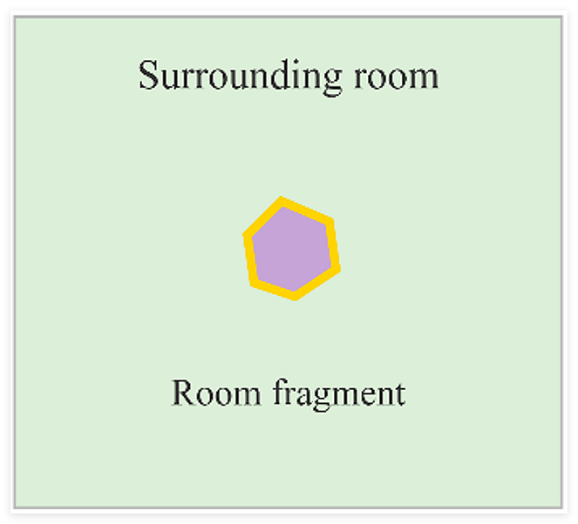 | 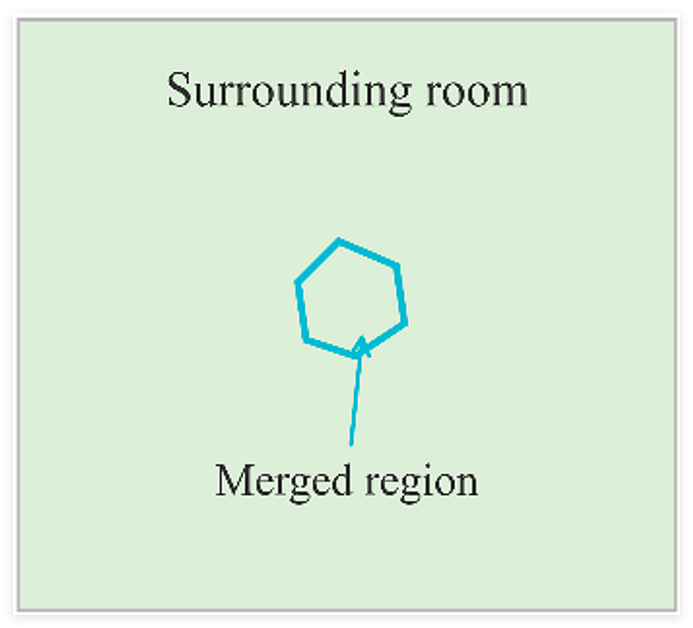
Misaligned wall boundary | 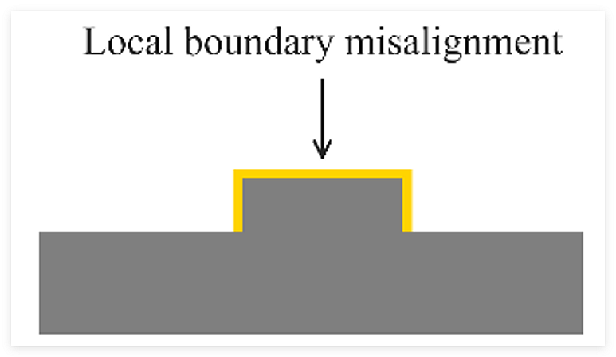 | 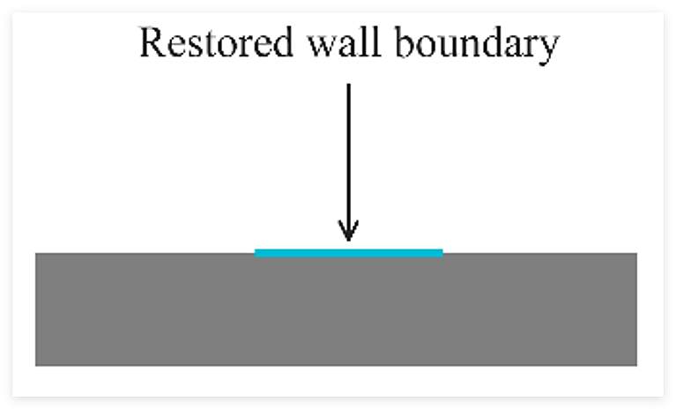
Short wall gap | 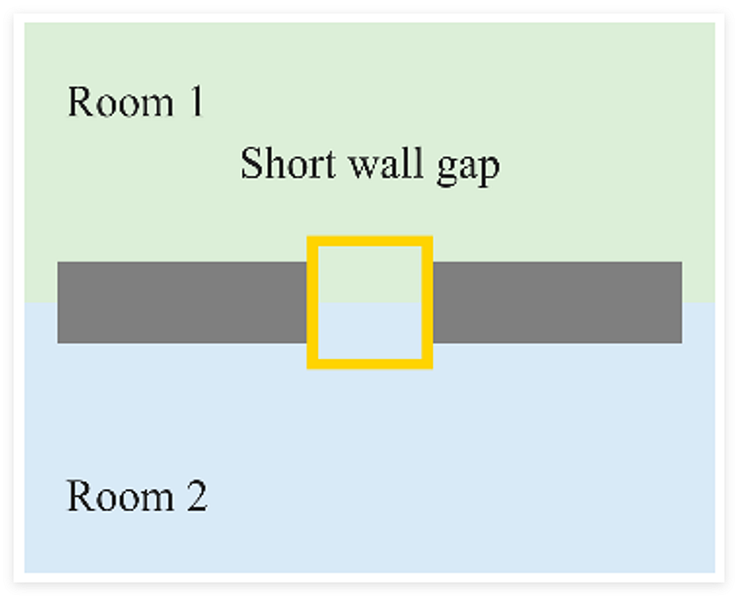 | 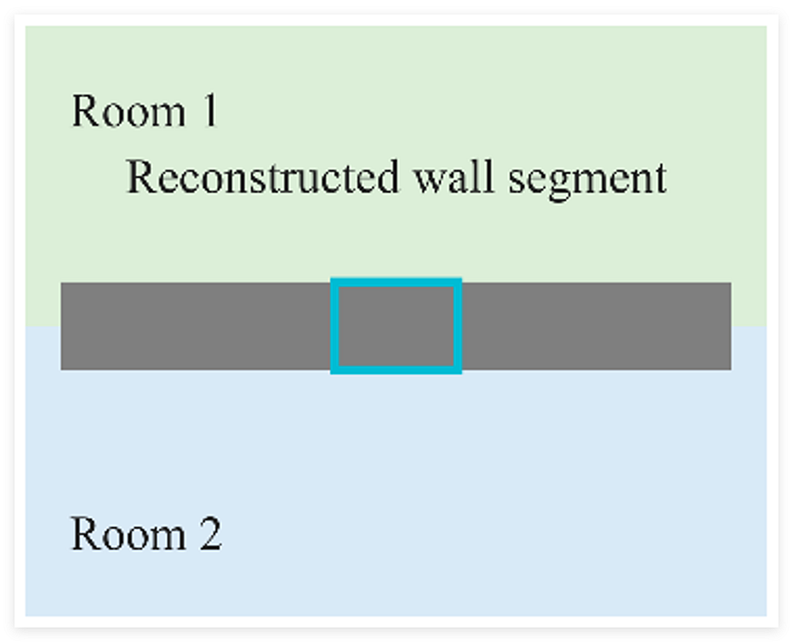
Displaced or incomplete opening | 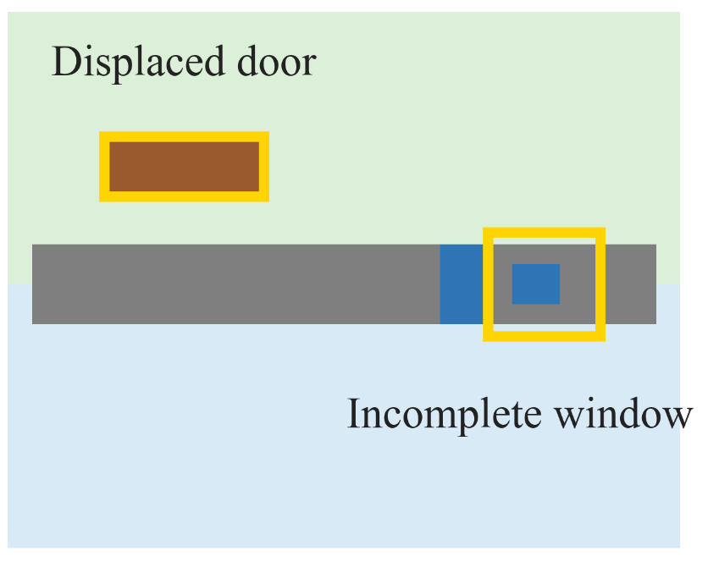 | 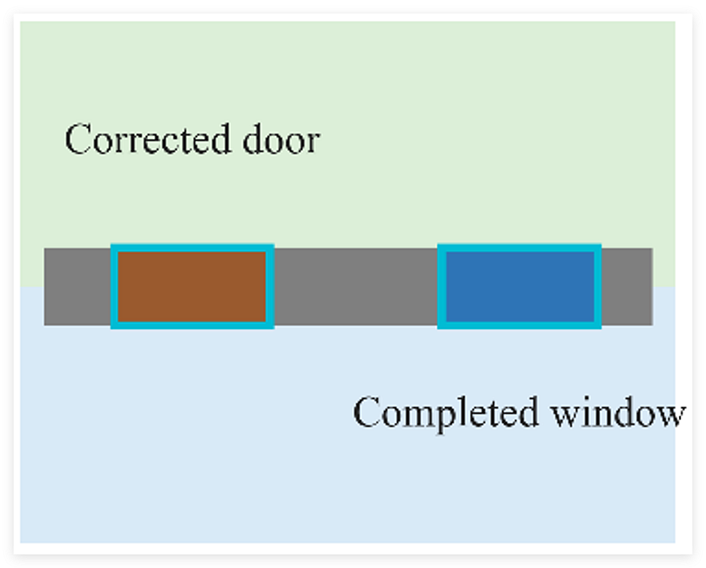
Fig. S1. Schematic illustration of self correction mechanisms. Yellow and cyan outlines indicate injected defects and corrected regions, respectively.
B.2. Segmentation Perturbation Study
The Geo-ELCT translator receives two segmentation outputs from the GNN: a room region map and an opening map containing doors and windows. Controlled perturbations are introduced directly into both maps. The room map is perturbed by adding enclosed noise artifacts, localized wall interruptions or terminal retractions, and local boundary displacements. The opening map is perturbed by shifting door or window components along their host walls or deleting portions of the components.
The Clean maps serve as the reference. Under the Mild, Moderate, and Severe conditions, the number and spatial scale of the injected defects progressively increase while the perturbation types remain unchanged. Five fixed random seeds are evaluated at each perturbation level. Table S1 shows representative perturbation examples for Seed 2.
TABLE S1
REPRESENTATIVE LOCAL PERTURBATIONS INTRODUCED INTO THE GNN SEGMENTATION OUTPUTS FOR SEED 2
Map type | Clean | Perturbation
Map type | Clean | Mild | Moderate | Severe
Room  maps | 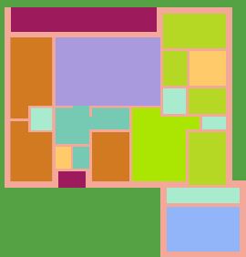 | 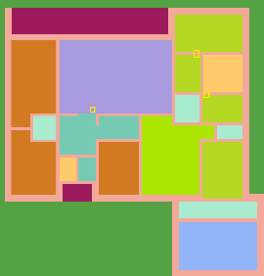 | 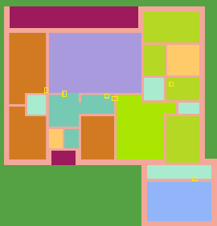 | 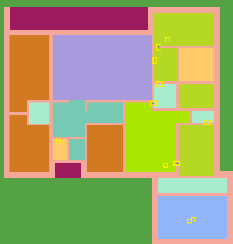
Opening  maps | 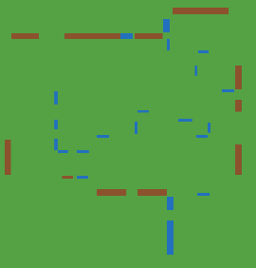 | 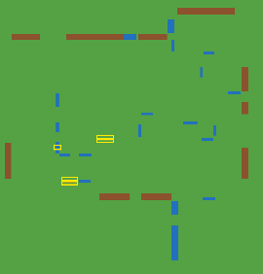 | 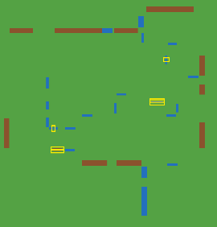 | 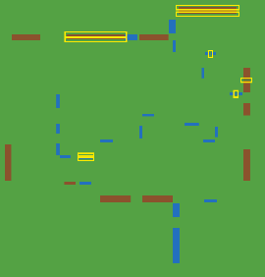
Note: Yellow outlines highlight the injected perturbations.
B.3. Topology Matching Results
A topology matches the Clean reference when the room count, connectivity between rooms, and connection types are all identical to the reference. Table S2 reports the number of matching trials out of five for each condition, with and without self correction.
TABLE S2
QUANTITATIVE EXACT MATCH EVALUATION RESULTS
Condition | Without self correction | With self correction
Clean | 5/5 | 5/5
Mild | 5/5 | 5/5
Moderate | 0/5 | 5/5
Severe | 0/5 | 5/5
Note: Each entry gives the number of trials matching the Clean topology out of five trials.
Without self correction, all five trials match the Clean reference under the Mild condition, whereas no trial satisfies the matching criterion under the Moderate or Severe condition. With self correction, all five trials match the reference at each evaluated perturbation level. These results concern topology matching under the stated criterion, not complete recovery of every geometric parameter or pixel.

Part C. MWM Calibration and Cross-Configuration Evaluation

C.1. Calibration and evaluation protocol
This part examines the influence of the calibration configuration on the Multi-Wall Model (MWM) predictions in Building C. The validation configurations C-1, C-2, and C-3 use transmitters in Room 1, Rooms 1 and 2, and Rooms 1, 2, and 4, respectively. C-4v uses transmitters in Rooms 1, 2, 4, and 18.
At each of 2.4, 5, and 28 GHz, the 18 room average received powers (ARPs) obtained from Wireless InSite (WI) are used to calibrate the four MWM parameters. The original C-1 parameter sets are retained, and nine additional sets are obtained using C-2, C-3, and C-4v separately at the three frequencies. Each set is then held fixed when evaluating all 18 rooms under all four configurations. All calibration sources use the same SVG geometry, receiver grid, wall and opening intersection counts, and WI room reference data.

C.2. Cross configuration results
Table S3 reports the mean absolute error (MAE) over the 18 rooms. Each row applies one calibrated parameter set to the four evaluation configurations. The C-1 rows retain the single calibration source used for the MWM baseline in Table VI of the manuscript.
TABLE S3
MWM MAE FOR DIFFERENT CALIBRATION AND EVALUATION CONFIGURATIONS IN BUILDING C
Frequency  (GHz) | Calibration  configuration | Evaluate C-1 | Evaluate C-2 | Evaluate C-3 | Evaluate C-4v
2.4 | C-1 | 2.30* | 2.04 | 1.77 | 1.15
2.4 | C-2 | 2.46 | 2.01* | 1.62 | 1.12
2.4 | C-3 | 3.37 | 2.19 | 1.48* | 1.16
2.4 | C-4v | 2.96 | 2.08 | 1.47 | 1.08*
5 | C-1 | 2.90* | 3.31 | 2.77 | 1.87
5 | C-2 | 3.37 | 2.82* | 2.35 | 1.83
5 | C-3 | 5.14 | 3.16 | 2.27* | 1.77
5 | C-4v | 5.53 | 3.05 | 2.21 | 1.60*
28 | C-1 | 10.41* | 11.80 | 9.81 | 8.46
28 | C-2 | 11.00 | 7.67* | 6.29 | 5.42
28 | C-3 | 14.31 | 9.53 | 6.50* | 5.93
28 | C-4v | 15.20 | 9.23 | 7.34 | 5.29*
Note: All values are MAEs in dB. Asterisks (*) mark fitting errors evaluated on the calibration data. Bold values indicate the lowest prediction MAE among the other calibration configurations for each evaluation target. Values are rounded to two decimal places. Differences are calculated using full precision.
At 2.4 GHz, alternative multiple transmitter calibration gives mixed changes on the other multiple transmitter configurations, ranging from a 0.15 dB increase to a 0.30 dB decrease in MAE relative to C-1 calibration. At 5 GHz, all corresponding comparisons improve, with reductions of 0.04 to 0.56 dB.
The improvement is strongest at 28 GHz, where the corresponding MAE reductions range from 2.27 to 3.52 dB. For example, using C-2 instead of C-1 for calibration reduces the MAE for C-3 from 9.81 to 6.29 dB and that for C-4v from 8.46 to 5.42 dB. The evaluation configurations are excluded from these parameter fits. Thus, C-1 alone can restrict MWM performance in the evaluated multiple transmitter scenarios.

C.3. Model and fitted parameters
The MWM retains the distance and wall/opening loss formulation used for the baseline comparison:
${PL}_{MWM} = FSPL(f, d_{0}) + b_{0} + 10n\log_{10}(\frac{d_{eff}}{d_{0}}) + L_{wall}N_{wall} + L_{open}N_{open}$
Here, d₀ = 1 m, d_{eff} = max(d_{3D}, d₀), and FSPL(f, d₀) = 32.4 + 20 log₁₀(f_{GHz}) dB, where f_{GHz} is the numerical frequency in GHz. N_{wall} and N_{open} count intersections of the direct Tx to Rx path with wall segments and door/window polygons, respectively. L_{open} is an effective coefficient for the combined opening category.
Calibration minimizes the equally weighted sum of squared differences between predicted and WI room ARPs. The intercept is unrestricted and the other three parameters are nonnegative. Each additional fit uses the same eight fixed initializations, and the retained solution is selected using only the calibration objective. Table S4 lists all parameter sets.
TABLE S4
MWM PARAMETERS FOR EACH CALIBRATION CONFIGURATION AND FREQUENCY
Frequency  (GHz) | Calibration  configuration | b₀ (dB) | n | L_{wall} (dB) | L_{open} (dB)
2.4 | C-1 | -0.156525 | 2.113317 | 1.506337 | 2.056363
2.4 | C-2 | 0.417037 | 1.727681 | 2.657989 | 2.629881
2.4 | C-3 | 0.042317 | 1.229450 | 4.952489 | 5.188911
2.4 | C-4v | 0.685120 | 1.253895 | 4.299355 | 4.599910
5 | C-1 | -0.857075 | 2.813174 | 2.125906 | 0.732865
5 | C-2 | -0.377660 | 2.059047 | 4.206460 | 1.244888
5 | C-3 | -1.135327 | 1.664586 | 7.252363 | 4.203859
5 | C-4v | 0.755918 | 1.116513 | 8.125106 | 5.897109
28 | C-1 | 2.483059 | 3.718605 | 5.016924 | 0.000000
28 | C-2 | -3.393007 | 2.897454 | 9.560211 | 0.000000
28 | C-3 | -6.217826 | 2.105529 | 17.281368 | 9.730139
28 | C-4v | -2.711578 | 2.228183 | 18.660189 | 2.120393
Note: The C-1 parameter sets are retained from the baseline calculation. Parameters are displayed to six decimal places, and the calculations use full precision.
The model uses a 0.15 m receiver grid with a 0.15 m inward clearance and heights of 0.765 and 1.06 m, giving 11,480 points. Each transmitter operates at 15 dBm and a height of 1.5 m, with 0 dBi antenna gains. The Room 18 transmitter retains its recorded geometric center. These model coordinates have not been independently matched to a WI coordinate export.

C.4. Comparison with the proposed framework
For each evaluation configuration and frequency, the lowest non-diagonal MWM MAE is compared with the corresponding Proposed Model MAE. Table S5 summarizes these results. The proposed framework has lower MAE in all 12 case and frequency combinations within the evaluated room reference dataset.
TABLE S5
LOWEST OBSERVED CROSS CONFIGURATION MWM MAE AND COMPARISON WITH THE PROPOSED FRAMEWORK
Frequency  (GHz) | Lowest cross configuration  MWM MAE (dB) | Proposed Model  MAE (dB) | Paired MAE difference  MWM minus Proposed (dB)
2.4 | 1.12 to 2.46 | 0.50 to 1.01 | 0.62 to 1.65
5 | 1.77 to 3.37 | 0.58 to 1.32 | 1.19 to 2.10
28 | 5.42 to 11.00 | 1.08 to 1.22 | 4.20 to 9.92
Note: Ranges cover the four evaluation configurations at each frequency. Paired differences are calculated for the same evaluation configuration before taking the range.
These minima are selected after evaluation and provide a favorable descriptive comparison. Table VI retains the C-1 calibration protocol. The analysis is confined to Building C, with shared receiving rooms and transmitter locations and separate calibration at each frequency.

